Project Schedules
• A stage of a larger project, the project plan must be developed to the level of showing dates
when each activity should start and finish and when and how much of each resource will be
required. Once the plan has been refined to this level of detail we call it a project schedule
• Creating a project schedule comprises four main stages.
First step
• Step in producing the plan is to decide what activities need to be carried out and in what order they are to be done_ From this we can construct an ideal activity plan — that is, a plan of when each activity would ideally be undertaken were resources not a constraint
• This activity plan is generated by Steps 4 and 5 of Step Wise
Second step
• The ideal activity plan will then be the subject of an activity risk analysis, aimed at identifying potential problems. This might suggest alterations to the ideal activity plan and will almost certainly have implications for resource allocation.
Third step
• This is resource allocation. The expected availability of resources might place constraints on when certain activities can be carried out
Final step
• The final step is schedule production. Once resources have been allocated to each activity,
we will be in a position to draw up and publish a project schedule, which indicates planned
start and completion dates and resource requirements statement for each activity.

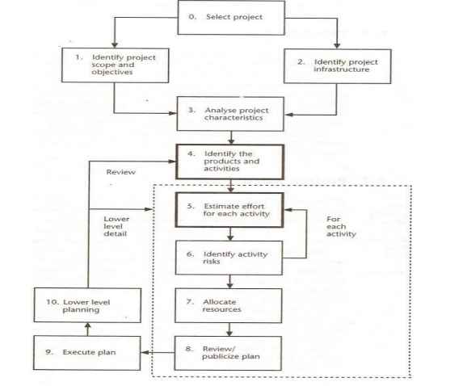
Activity planning is carried out in step 4 and step 5

